Network rewiring conserves the topology of drought-impaired food webs

Table 1. Drought altered species network properties. The degree, eigenvector centrality, and PageRank of survived species were compared between control and drought webs using linear mixed effects models with species identity nested within paired web identity as the random effect. Subsequently, the survived species were sub-divided into consumer species and resource species. Degrees of freedom (DF), F-values, and p-values from the model outputs are shown in the table.

All species | DF | F-value | p-value
Degree | 178 | 51.34 | < 0.0001
Eigenvector centrality | 178 | 66.92 | < 0.0001
PageRank | 178 | 31.75 | < 0.0001
Consumer species
Degree | 66 | 2.01 | 0.1609
Eigenvector centrality | 66 | 26.44 | < 0.0001
PageRank | 66 | 32.99 | < 0.0001
Resource species
Degree | 111 | 76.30 | < 0.0001
Eigenvector centrality | 111 | 50.33 | < 0.0001
PageRank | 111 | 4.94 | 0.0283

Fig. 1. The concept of topological network alignment. a, Network and b, Network . In both cases, nodes are listed in alphabetical order and only the top half of the adjacency matrix is shown. The two networks appear to be very different in terms of their network diagrams and adjacency matrices, but their network patterns are not directly comparable in their current forms. c-d, Network alignment overlays on so as to maximise the similarity of the overall topology. Nodes in the matrix of are divided into aligned and non-aligned and listed in ascending order of degree within each group, while nodes in the matrix of have been placed at the same matrix entries as their aligned counterparts to visualise the alignment between nodes. In this example, node V has been assigned to the first entry of its matrix due to its alignment with node B. For the same reason, node Y has been aligned with node F and therefore has been placed at the sixth entry of its matrix. Edges in the network diagrams are divided into those that are conserved (solid) or unique (dashed) to their respective networks. In the matrices, edges are either associated with aligned nodes (filled circles) or non-aligned nodes (not filled circles). The number of conserved edges by the alignment = 6 (dark circles). The number of edges in the aligned region of and are = 7 (6 dark and 1 light circles) and = 8 (6 dark and 2 light circles) respectively, giving a score of 6 / (7 + 8 – 6) = 0.67.

Fig. 2. Network alignment reveals similar topological patterns in control-drought pair of webs but formed by different interactions. a, binary matrix of a control web (Methods), with links that are common to the control and drought pair of webs (dark blue circles) and those have been lost following drought (unfilled grey circles). Only the top halves of the aligned regions are shown (Supplementary Fig. 1a-b). b, binary matrix of the respective drought web, with rewired links (light blue circles) and those by invasive consumers (unfilled pink circles). Network alignment overlaid the drought matrix with that of the control to maximise similarity in their topologies. Extensive dietary changes among consumers following drought have collectively altered the interactions that formed the aligned network patterns (Supplementary Fig. 1c,d). c-d, simplified trophic diagrams of (a) and (b) respectively, whereby consumers are in the top row and resources are in the bottom row. Species included those who survived (dark circles) or went extinct (grey circles), and invasive species (pink circles). Both consumers and resources are arranged in descending order of degree from the centre. The pattern of the aligned control web (c) shows a wide range of consumers feeding on a smaller range of resources species; whilst the pattern of the drought web (d) is formed by a much smaller range of consumers feeding over a wider range of resource species (Supplementary Fig 1e,f).

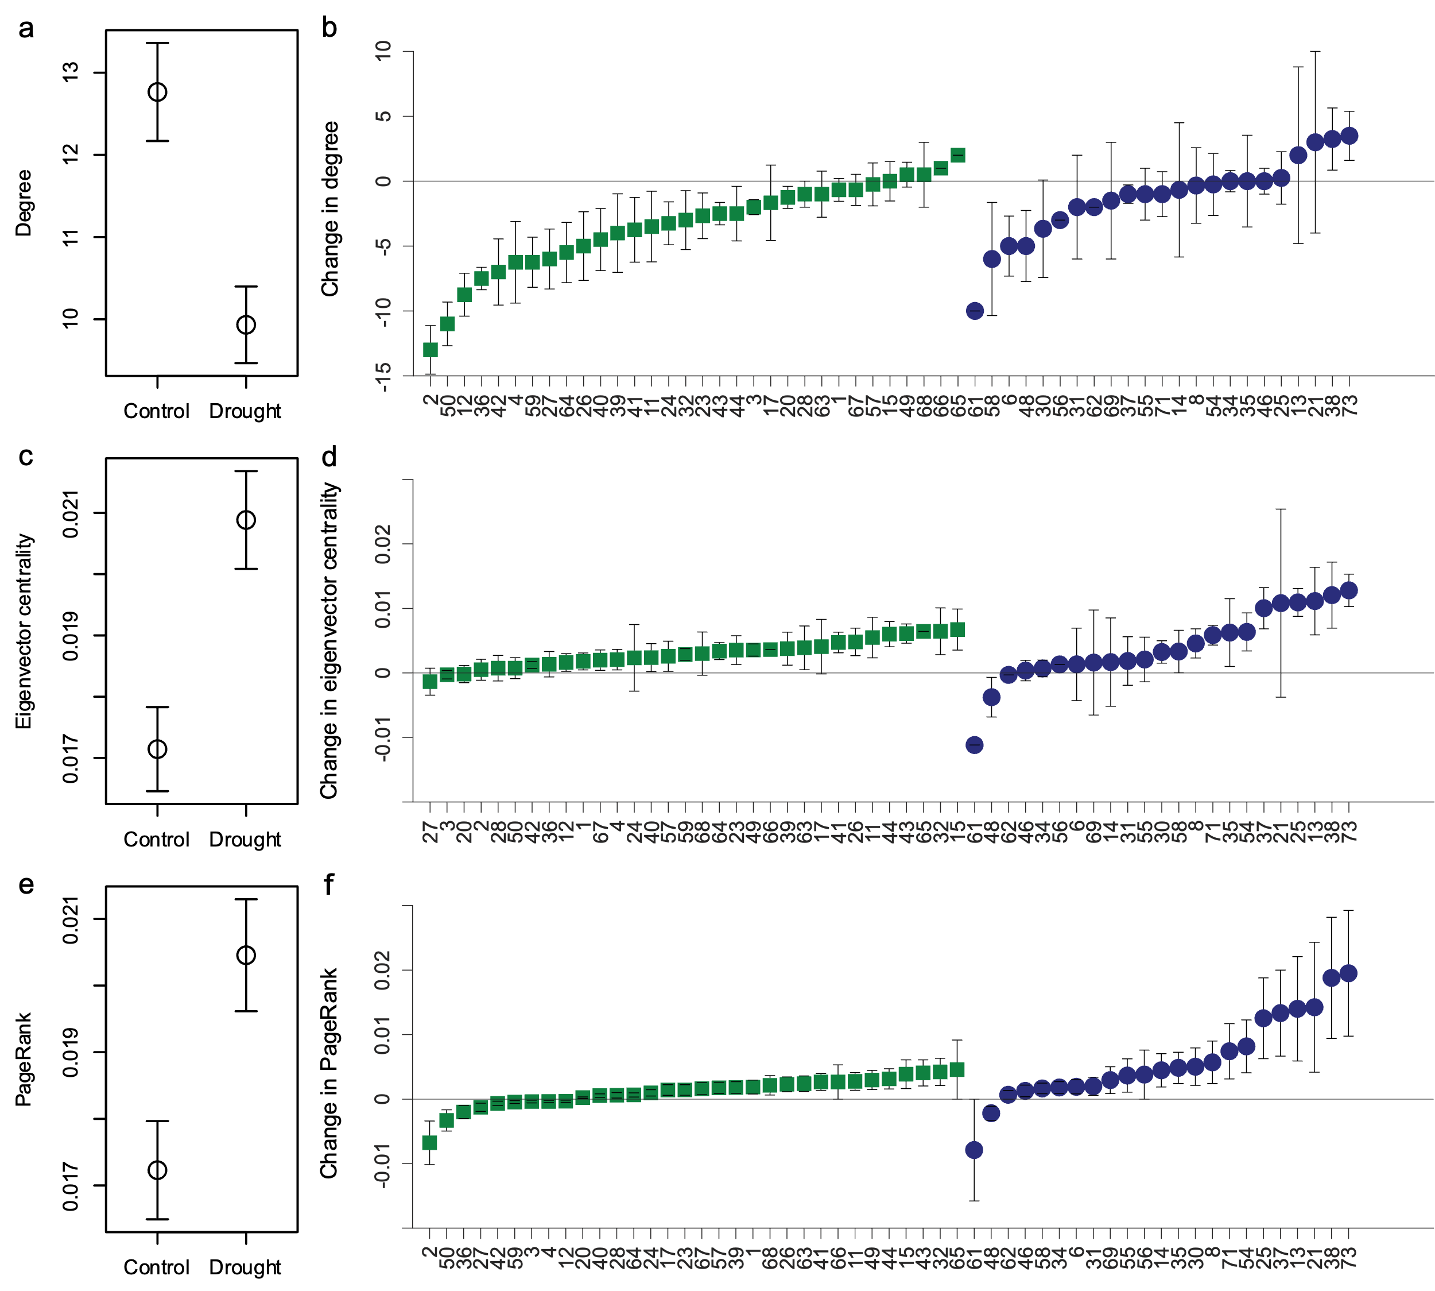

Fig. 3. Drought increases interconnectedness among species. a,c,e, Network- and b,d,f, node-level differences in (a,b) degree, (c,d) eigenvector centrality, and (e,f) PageRank between control and drought food webs among resource species (green squares, i.e. those without any resources) and consumer species (blue circles, i.e. those with resources which can be with or without consumers themselves). See Table 1 for statistical comparisons between treatments. Only species ID are shown in the x-axes, see Supplementary Table 5 for the reference list of species.

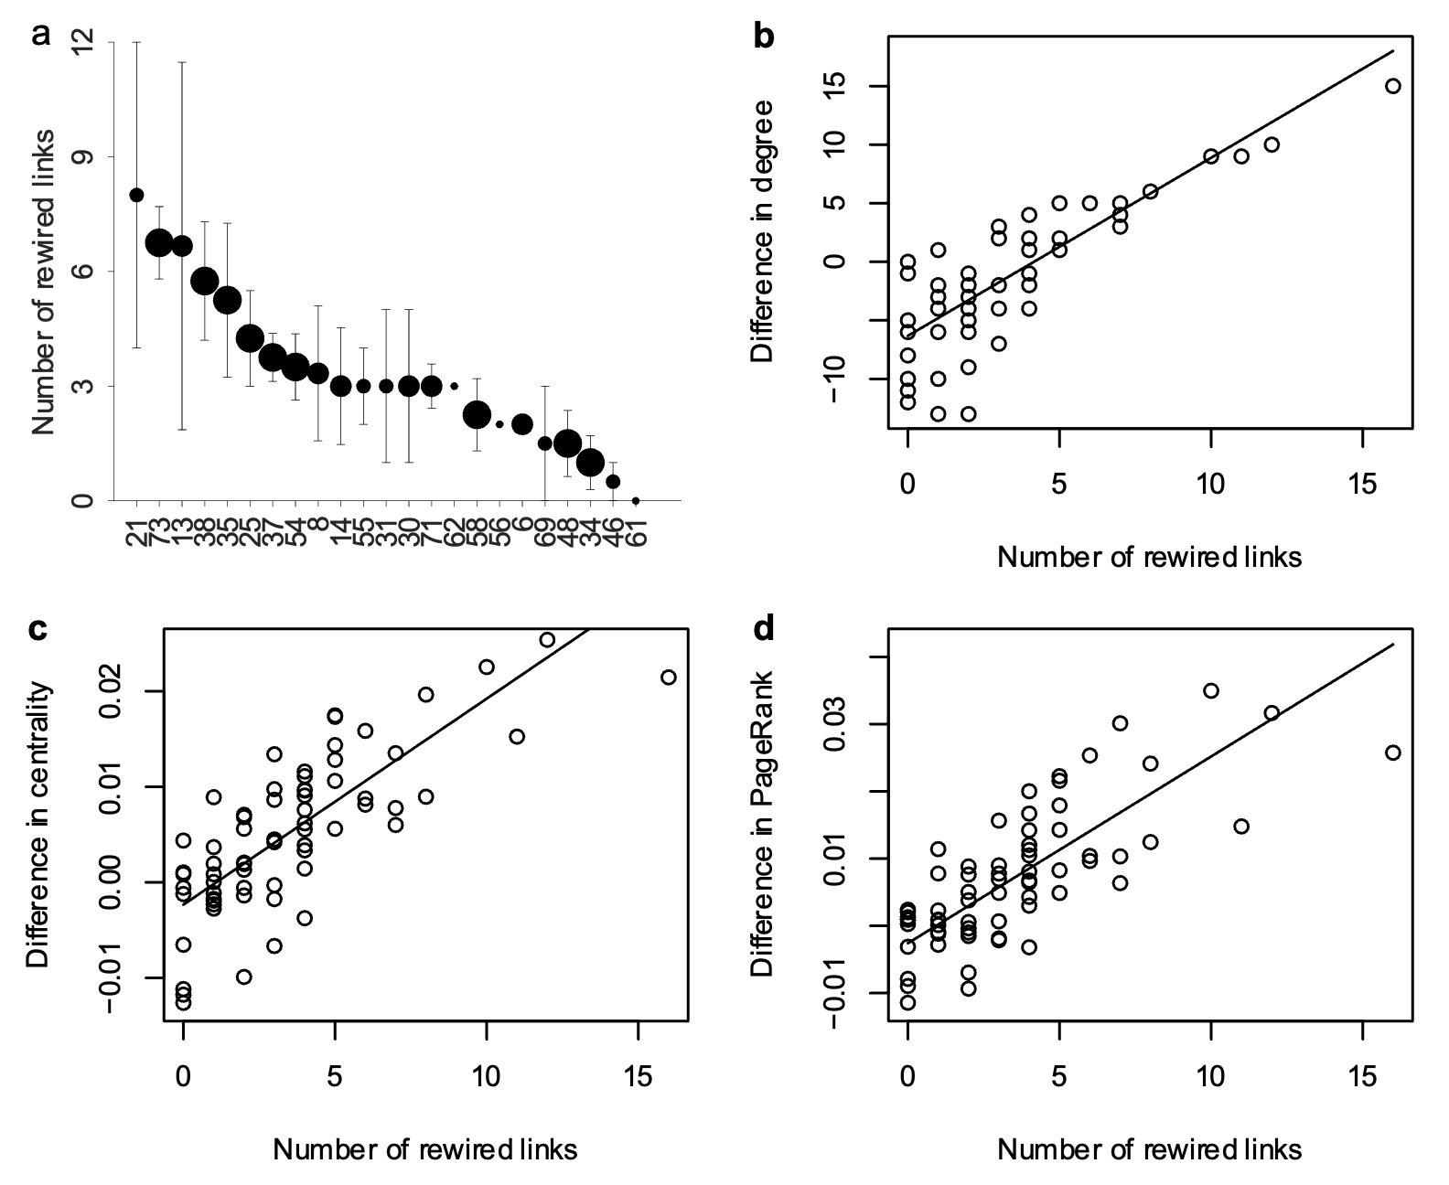

Fig. 4. Rewiring alters network properties of species. a, The mean number of rewired links among the survived consumer species (marker size indicates the number of replicates in which the species was present). b-d, The greater the number of rewired links among species, the greater the changes in node-level properties in the drought webs, including: (b) degree (F_{1,44} = 139.8, P < 0.0001, r² = 0.74; y = -6.3235 + 1.5205x), (c) eigenvector centrality (F_{1,62} = 111.1, P < 0.0001, r² = 0.71; y = -0.0023 + 0.0022x), and (d) PageRank (F_{1,64} = 121.9, P < 0.0001, r² = 0.76; y = -0.0026 + 0.0028x). Note that the degrees of freedom are based on Satterthwaite's method, with n = 67 for each metric.

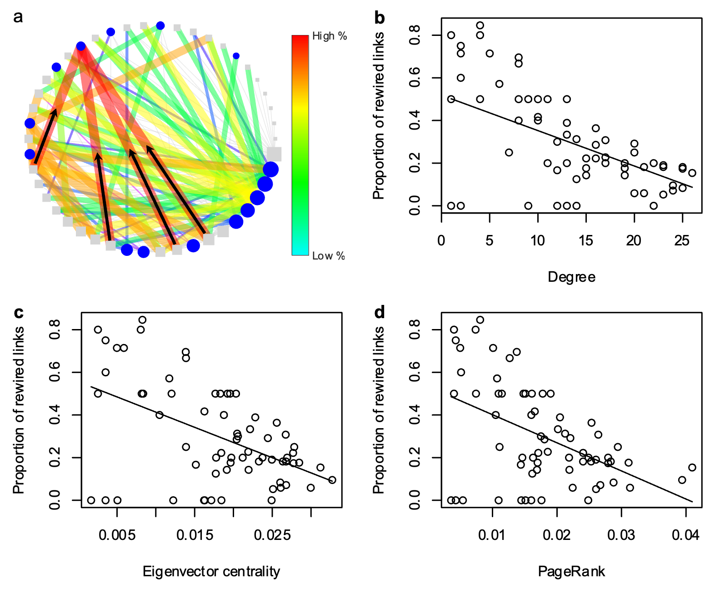

Fig. 5. Adaptability among poorly connected species governs persistence in the face of drought. a, Specialist species with narrower diets were found to have rewired proportionally more than generalist species. Consumer (blue circles) and resource species (grey squares) are placed in ascending order of degree, indicated by node size. Links are divided into unaltered links from the control web (unweighted grey lines) and rewired links that are only found in the drought web (weighted colour lines), both colour and weight indicate the proportion of rewired links of a given species. An example of a low degree consumer with a high proportion of rewired links is shown, with the transfer of energy fluxes from new resource species indicated by black arrows. See Supplementary Fig. 4 for all webs. b-d, The proportion of links that were rewired in the drought webs decreased with: (b) degree (F_{1,31} = 21.65, P < 0.0001, r² = 0.47; y = 0.5186 - 0.0166x), (c) eigenvector centrality (F_{1,29} = 23.07, P < 0.0001, r² = 0.55; y = 0.5559 - 14.25x), and (d) PageRank (F_{1,33} = 22.46, P < 0.0001, r² = 0.55; y = 0.5331 – 13.18x). Note that the degrees of freedom are based on Satterthwaite’s method, with n = 67 for each metric.

Network rewiring conserves the topology of drought-impaired food webs

Supplementary Figures and Tables

Supplementary Table 1. Rewiring observed in all webs. For each drought web, the proportions of surviving species and unaltered links, which are nodes and links that are common to both webs, are listed. The proportion of rewired links in each drought web was calculated by referring to the surviving species only (Exc. Invasion), and by referring to all links including species that invaded the drought webs (All). The Jaccard Index among nodes and links between each web pair are also provided, together with the overall mean values and standard deviations (S.D.) across all webs.
 | Unaltered  in drought web |  | Rewiring in drought web |  | The Jaccard index between web pairs
web | Nodes | Links | Exc. Invasion | All | Nodes | Links
1 | 0.91 | 0.58 | 0.32 | 0.42 | 0.32 | 0.62
2 | 0.87 | 0.48 | 0.36 | 0.52 | 0.42 | 0.79
3 | 0.92 | 0.69 | 0.12 | 0.31 | 0.31 | 0.67
4 | 0.96 | 0.66 | 0.17 | 0.34 | 0.25 | 0.66
Mean | 0.92 | 0.60 | 0.24 | 0.40 | 0.33 | 0.69
S.D. | 0.04 | 0.09 | 0.12 | 0.09 | 0.07 | 0.07

Supplementary Table 2. High level of topological similarity between control and drought web pairs. For each pair of webs, the mean S³ scores from 30 runs are shown, together with the overall mean values and standard deviations (S.D.) across all webs. The mean S³ scores between control and 30 randomised drought webs are also shown by comparing the results from the empirical webs with the null model. Note that the z-score indicates the number of standard deviations that the empirical webs lie from the mean of the randomisations.
 | Empirical webs |  | Empirical control and randomised drought webs
Food web pair | S³ | S.D. | S³ | S.D. | z-score
1 | 0.79 | 0.01 | 0.47 | 0.01 | 32
2 | 0.83 | 0.01 | 0.51 | 0.01 | 32
3 | 0.81 | 0.02 | 0.48 | 0.01 | 33
4 | 0.78 | 0.01 | 0.49 | 0.01 | 25
Mean | 0.80 | 0.02 | 0.49 | 0.01 | 30.5

Supplementary Table 3. Trophic plasticity restored densely connected regions in food webs. For each pair of webs, the connectance of the control, aligned subgraph in control and drought are shown, together with mean values and standard deviations (S.D.) across all webs.

Food web pair | Control | Aligned control subgraph | Drought
1 | 0.0862 | 0.1123 | 0.1254
2 | 0.0756 | 0.0893 | 0.0879
3 | 0.0806 | 0.1125 | 0.0991
4 | 0.0710 | 0.0991 | 0.0973
Mean | 0.0783 | 0.1033 | 0.1024
S.D. | 0.0065 | 0.0112 | 0.0161

Supplementary Table 4. The number of consumers and resources in each web.

Food web pair | Control |  | Drought
 | Consumers | Resources | Consumers | Resources
1 | 30 | 29 | 21 | 26
2 | 34 | 29 | 16 | 30
3 | 31 | 30 | 18 | 31
4 | 33 | 32 | 21 | 31
Mean | 32 | 30 | 19 | 29.5
S.D. | 1.8257 | 1.1442 | 2.4495 | 2.3805

Supplementary Table 5. Species ID and their names.

1 | Algal cysts
2 | Amorphus detritus
3 | Amphora ovalis
4 | Amphora pediculus
5 | Ancylus fluviatilis
6 | Asellus aquaticus
7 | Athripsodes sp.
8 | Baetis sp.
9 | Brachycentrus subnubilus
10 | Brychius elevatus
11 | Chrococcus minor
12 | Cocconeis placentula
13 | Cricotopus sp.
14 | Cryptochironomus sp.
15 | Cymatopleura solea
16 | Cymbella lanceolata
17 | Diatoma vulgare
19 | Elmis aenea
20 | Encyonema minutum
21 | Ephemera danica
22 | Erpobdella octoculata
23 | Fragilaria vaucheriae
24 | Fungal spores
25 | Gammarus pulex
26 | Gomphonema olivaceum
27 | Gongrosira incrustans
28 | Gyrosigma sp.
29 | Haliplus lineatocollis
30 | Heterotrissocladius sp.
31 | Hydropsyche sp.
32 | Hyphomycete fungal hyphae
33 | Leuctra geniculata
34 | Limnius volckmari
35 | Macropelopia sp.
36 | Melosira varians
37 | Microtendipes sp.
38 | Naididae

39 | Navicula gregaria
40 | Navicula lanceolata
41 | Navicula menisculus
42 | Navicula tripunctata
43 | Nitzschia dissipata
44 | Nitzschia perminuta
45 | Ostracoda
46 | Oulimnius tuberculatus
47 | Pentaneura sp.
48 | Pisidium sp.
49 | Planothidium lanceolatum
50 | Plant fragments
51 | Platambus maculatus
52 | Polycentropus flavomaculatus
53 | Polypedilum sp.
54 | Potamopyrgus antipodarum
55 | Procladius sp.
56 | Prodiamesa olivacea
57 | Psammothidium lauenburgianum
58 | Radix balthica
59 | Rhoicosphenia abbreviata
60 | Sericostoma personatum
61 | Sialis lutaria
62 | Simuliidae
63 | Spirulina sp.
64 | Staurosira elliptica
65 | Staurosirella leptostauron
66 | Surirella brebissonii
67 | Surirella minuta
68 | Synedra ulna
69 | Synorthocladius sp.
70 | Theodoxus fluviatilis
71 | Tinodes waeneri
72 | Tipula montium
73 | Tubificidae
74 | Valvata piscinalis

Supplementary Table 6. Species alignment in control and drought pair of webs 1. Species in the control web are grouped into aligned and non-aligned groups. Within a group, survived species (non-shaded) are listed first in ascending order of body mass, followed by extinct species (shaded) in the same order. Species in the drought web are listed against their counterpart species in the control web based on the network alignment results. An asterisk (*) denotes an invaded species.
Web pair 1 | Species in control web | Trophic group | Aligned species in drought web |  | Trophic group
Aligned | Amorphus detritus | Detritus |  | Tubificidae | Detritivore
 | Plant fragments | Detritus |  | Cricotopus sp. | Herbivore
 | Fungal spores | Decomposer |  | Heterotrissocladius sp. | Detritivore
 | Hyphomycete fungal hyphae | Decomposer |  | Tinodes waeneri | Herbivore
 | Chrococcus minor | Primary producer |  | Microtendipes sp. | Herbivore
 | Psammothidium lauenburgianum | Primary producer |  | Cryptochironomus sp. | Herbivore
 | Gomphonema olivaceum | Primary producer |  | Naididae | Detritivore
 | Amphora pediculus | Primary producer |  | Ephemera danica | Detritivore
 | Planothidium lanceolatum | Primary producer |  | Oulimnius tuberculatus | Detritivore
 | Encyonema minutum | Primary producer |  | Limnius volckmari | Detritivore
 | Gongrosira incrustans | Primary producer |  | Gammarus pulex | Detritivore
 | Melosira varians | Primary producer |  | Radix balthica | Herbivore
 | Cocconeis placentula | Primary producer |  | Baetis sp. | Herbivore
 | Navicula menisculus | Primary producer |  | Pisidium sp. | Detritivore
 | Nitzschia dissipata | Primary producer | * | Eiseniella tetraedra | Detritivore
 | Nitzschia perminuta | Primary producer |  | Macropelopia sp. | Predator
 | Rhoicosphenia abbreviata | Primary producer |  | Potamopyrgus antipodarum | Herbivore
 | Navicula tripunctata | Primary producer |  | Simuliidae | Detritivore
 | Navicula lanceolata | Primary producer |  | Hydropsyche sp. | Predator
 | Spirulina sp. | Primary producer | * | Synorthocladius sp. | Herbivore
 | Naididae | Detritivore |  | Chrococcus minor | Primary producer
 | Oulimnius tuberculatus | Detritivore | * | Staurosirella leptostauron | Primary producer
 | Heterotrissocladius sp. | Detritivore |  | Gongrosira incrustans | Primary producer
 | Simuliidae | Detritivore |  | Cocconeis placentula | Primary producer
 | Tubificidae | Detritivore |  | Nitzschia perminuta | Primary producer
 | Pisidium sp. | Detritivore |  | Fungal spores | Decomposer
 | Gammarus pulex | Detritivore |  | Amphora pediculus | Primary producer
 | Ephemera danica | Detritivore |  | Rhoicosphenia abbreviata | Primary producer
 | Cricotopus sp. | Herbivore |  | Synedra ulna | Primary producer
 | Cryptochironomus sp. | Herbivore |  | Surirella minuta | Primary producer
 | Microtendipes sp. | Herbivore |  | Amorphus detritus | Detritus
 | Tinodes waeneri | Herbivore |  | Navicula tripunctata | Primary producer
 | Baetis sp. | Herbivore |  | Nitzschia dissipata | Primary producer
 | Potamopyrgus antipodarum | Herbivore |  | Navicula menisculus | Primary producer
 | Radix balthica | Herbivore |  | Gomphonema olivaceum | Primary producer
 | Hydropsyche sp. | Predator |  | Navicula gregaria | Primary producer
 | Amphora ovalis | Primary producer | * | Sialis lutaria | Predator
 | Cymatopleura solea | Primary producer | * | Gyrosigma sp. | Primary producer
 | Ostracoda | Detritivore |  | Encyonema minutum | Primary producer
 | Leuctra geniculata | Detritivore |  | Psammothidium lauenburgianum | Primary producer
 | Polypedilum sp. | Detritivore |  | Spirulina sp. | Primary producer
 | Elmis aenea | Detritivore |  | Planothidium lanceolatum | Primary producer
 | Asellus aquaticus | Detritivore |  | Melosira varians | Primary producer
 | Sericostoma personatum | Detritivore |  | Navicula lanceolata | Primary producer
 | Athripsodes sp. | Herbivore |  | Staurosira elliptica | Primary producer
 | Brachycentrus subnubilus | Herbivore |  | Plant fragments | Detritus
 | Ancylus fluviatilis | Herbivore |  | Hyphomycete fungal hyphae | Decomposer
Non-aligned | Staurosira elliptica | Primary producer
 | Surirella minuta | Primary producer
 | Navicula gregaria | Primary producer
 | Synedra ulna | Primary producer
 | Limnius volckmari | Detritivore
 | Macropelopia sp. | Predator
 | Fragilaria vaucheriae | Primary producer
 | Algal cysts | Primary producer
 | Diatoma vulgare | Primary producer
 | Brychius elevatus | Herbivore
 | Polycentropus flavomaculatus | Predator
 | Erpobdella octoculata | Predator
Supplementary Table 7. Species alignment in control and drought pair of webs 2. Species in the control web are grouped into aligned and non-aligned groups. Within a group, survived species (non-shaded) are listed first in ascending order of body mass, followed by extinct species (shaded) in the same order. Species in the drought web are listed against their counterpart species in the control web based on the network alignment results. An asterisk (*) denotes an invaded species.
Web pair 2 | Species in control web | Trophic group | Aligned species in drought web |  | Trophic group
Aligned | Amorphus detritus | Detritus | * | Tipula montium | Detritivore
 | Plant fragments | Detritus |  | Naididae | Detritivore
 | Hyphomycete fungal hyphae | Decomposer |  | Macropelopia sp. | Predator
 | Staurosira elliptica | Primary producer |  | Ephemera danica | Detritivore
 | Gomphonema olivaceum | Primary producer |  | Gammarus pulex | Detritivore
 | Amphora pediculus | Primary producer |  | Potamopyrgus antipodarum | Herbivore
 | Encyonema minutum | Primary producer |  | Pisidium sp. | Detritivore
 | Cocconeis placentula | Primary producer |  | Microtendipes sp. | Herbivore
 | Navicula gregaria | Primary producer |  | Cryptochironomus sp. | Herbivore
 | Rhoicosphenia abbreviata | Primary producer |  | Tubificidae | Detritivore
 | Algal cysts | Primary producer |  | Synorthocladius sp. | Herbivore
 | Navicula tripunctata | Primary producer |  | Radix balthica | Herbivore
 | Amphora ovalis | Primary producer |  | Limnius volckmari | Detritivore
 | Navicula lanceolata | Primary producer |  | Tinodes waeneri | Herbivore
 | Cymatopleura solea | Primary producer |  | Procladius sp. | Herbivore
 | Spirulina sp. | Primary producer |  | Asellus aquaticus | Detritivore
 | Tubificidae | Detritivore |  | Staurosira elliptica | Primary producer
 | Gammarus pulex | Detritivore |  | Hyphomycete fungal hyphae | Decomposer
 | Pisidium sp. | Detritivore |  | Navicula lanceolata | Primary producer
 | Asellus aquaticus | Detritivore |  | Chrococcus minor | Primary producer
 | Ephemera danica | Detritivore |  | Algal cysts | Primary producer
 | Synorthocladius sp. | Herbivore |  | Amphora ovalis | Primary producer
 | Procladius sp. | Herbivore |  | Diatoma vulgare | Primary producer
 | Cryptochironomus sp. | Herbivore |  | Surirella minuta | Primary producer
 | Tinodes waeneri | Herbivore |  | Navicula tripunctata | Primary producer
 | Potamopyrgus antipodarum | Herbivore |  | Nitzschia perminuta | Primary producer
 | Radix balthica | Herbivore |  | Amorphus detritus | Detritus
 | Macropelopia sp. | Predator |  | Planothidium lanceolatum | Primary producer
 | Heterotrissocladius sp. | Detritivore |  | Navicula gregaria | Primary producer
 | Polypedilum sp. | Detritivore | * | Surirella brebissonii | Primary producer
 | Simuliidae | Detritivore |  | Navicula menisculus | Primary producer
 | Elmis aenea | Detritivore |  | Nitzschia dissipata | Primary producer
 | Oulimnius tuberculatus | Detritivore | * | Gyrosigma sp. | Primary producer
 | Sericostoma personatum | Detritivore |  | Gomphonema olivaceum | Primary producer
 | Cricotopus sp. | Herbivore |  | Cymatopleura solea | Primary producer
 | Athripsodes sp. | Herbivore |  | Spirulina sp. | Primary producer
 | Brachycentrus subnubilus | Herbivore |  | Plant fragments | Detritus
 | Brychius elevatus | Herbivore |  | Fragilaria vaucheriae | Primary producer
 | Ancylus fluviatilis | Herbivore |  | Melosira varians | Primary producer
 | Valvata piscinalis | Herbivore |  | Cocconeis placentula | Primary producer
 | Theodoxus fluviatilis | Herbivore |  | Amphora pediculus | Primary producer
 | Pentaneura sp. | Predator |  | Psammothidium lauenburgianum | Primary producer
 | Polycentropus flavomaculatus | Predator |  | Rhoicosphenia abbreviata | Primary producer
 | Hydropsyche sp. | Predator |  | Fungal spores | Decomposer
 | Haliplus lineatocollis | Predator |  | Encyonema minutum | Primary producer
 | Sialis lutaria | Predator |  | Gongrosira incrustans | Primary producer
Non-aligned | Fungal spores | Decomposer
 | Chrococcus minor | Primary producer
 | Psammothidium lauenburgianum | Primary producer
 | Planothidium lanceolatum | Primary producer
 | Gongrosira incrustans | Primary producer
 | Melosira varians | Primary producer
 | Navicula menisculus | Primary producer
 | Surirella minuta | Primary producer
 | Nitzschia dissipata | Primary producer
 | Nitzschia perminuta | Primary producer
 | Fragilaria vaucheriae | Primary producer
 | Diatoma vulgare | Primary producer
 | Naididae | Detritivore
 | Limnius volckmari | Detritivore
 | Microtendipes sp. | Herbivore
 | Staurosirella leptostauron | Primary producer
 | Erpobdella octoculata | Predator

Supplementary Table 8. Species alignment in control and drought pair of webs 3. Species in the control web are grouped into aligned and non-aligned groups. Within a group, survived species (non-shaded) are listed first in ascending order of body mass, followed by extinct species (shaded) in the same order. Species in the drought web are listed against their counterpart species in the control web based on the network alignment results. An asterisk (*) denotes an invaded species.
Web pair 3 | Species in control web | Trophic group | Aligned species in drought web |  | Trophic group
Aligned | Amorphus detritus | Detritus |  | Tubificidae | Detritivore
 | Plant fragments | Detritus |  | Microtendipes sp. | Herbivore
 | Fungal spores | Decomposer |  | Pisidium sp. | Detritivore
 | Chrococcus minor | Primary producer |  | Baetis sp. | Herbivore
 | Staurosira elliptica | Primary producer |  | Cricotopus sp. | Herbivore
 | Psammothidium lauenburgianum | Primary producer | * | Cryptochironomus sp. | Herbivore
 | Gomphonema olivaceum | Primary producer |  | Asellus aquaticus | Detritivore
 | Amphora pediculus | Primary producer | * | Eiseniella tetraedra | Detritivore
 | Staurosirella leptostauron | Primary producer | * | Cymbella lanceolata | Primary producer
 | Encyonema minutum | Primary producer |  | Encyonema minutum | Primary producer
 | Melosira varians | Primary producer |  | Heterotrissocladius sp. | Detritivore
 | Navicula menisculus | Primary producer |  | Tinodes waeneri | Herbivore
 | Navicula gregaria | Primary producer |  | Naididae | Detritivore
 | Nitzschia dissipata | Primary producer | * | Brachycentrus subnubilus | Herbivore
 | Nitzschia perminuta | Primary producer |  | Radix balthica | Herbivore
 | Rhoicosphenia abbreviata | Primary producer |  | Gammarus pulex | Detritivore
 | Algal cysts | Primary producer |  | Macropelopia sp. | Predator
 | Navicula tripunctata | Primary producer |  | Potamopyrgus antipodarum | Herbivore
 | Amphora ovalis | Primary producer |  | Limnius volckmari | Detritivore
 | Gyrosigma sp. | Primary producer |  | Sialis lutaria | Predator
 | Naididae | Detritivore |  | Melosira varians | Primary producer
 | Tubificidae | Detritivore |  | Amphora pediculus | Primary producer
 | Pisidium sp. | Detritivore |  | Fungal spores | Decomposer
 | Limnius volckmari | Detritivore |  | Cymatopleura solea | Primary producer
 | Asellus aquaticus | Detritivore |  | Navicula tripunctata | Primary producer
 | Gammarus pulex | Detritivore |  | Cocconeis placentula | Primary producer
 | Tinodes waeneri | Herbivore |  | Navicula lanceolata | Primary producer
 | Cricotopus sp. | Herbivore |  | Navicula gregaria | Primary producer
 | Microtendipes sp. | Herbivore |  | Gomphonema olivaceum | Primary producer
 | Baetis sp. | Herbivore |  | Nitzschia perminuta | Primary producer
 | Potamopyrgus antipodarum | Herbivore |  | Chrococcus minor | Primary producer
 | Radix balthica | Herbivore |  | Plant fragments | Detritus
 | Macropelopia sp. | Predator |  | Algal cysts | Primary producer
 | Surirella minuta | Primary producer |  | Psammothidium lauenburgianum | Primary producer
 | Ostracoda | Detritivore | * | Surirella brebissonii | Primary producer
 | Elmis aenea | Detritivore |  | Planothidium lanceolatum | Primary producer
 | Oulimnius tuberculatus | Detritivore |  | Diatoma vulgare | Primary producer
 | Simuliidae | Detritivore |  | Navicula menisculus | Primary producer
 | Ephemera danica | Detritivore |  | Gongrosira incrustans | Primary producer
 | Tipula montium | Detritivore |  | Nitzschia dissipata | Primary producer
 | Synorthocladius sp. | Herbivore |  | Fragilaria vaucheriae | Primary producer
 | Athripsodes sp. | Herbivore |  | Hyphomycete fungal hyphae | Decomposer
 | Ancylus fluviatilis | Herbivore |  | Rhoicosphenia abbreviata | Primary producer
 | Valvata piscinalis | Herbivore |  | Amorphus detritus | Detritus
 | Pentaneura sp. | Predator |  | Spirulina sp. | Primary producer
 | Polycentropus flavomaculatus | Predator |  | Staurosirella leptostauron | Primary producer
 | Haliplus lineatocollis | Predator |  | Gyrosigma sp. | Primary producer
 | Hydropsyche sp. | Predator |  | Staurosira elliptica | Primary producer
 | Platambus maculatus | Predator |  | Amphora ovalis | Primary producer
Non-aligned | Hyphomycete fungal hyphae | Decomposer
 | Planothidium lanceolatum | Primary producer
 | Gongrosira incrustans | Primary producer
 | Cocconeis placentula | Primary producer
 | Fragilaria vaucheriae | Primary producer
 | Diatoma vulgare | Primary producer
 | Navicula lanceolata | Primary producer
 | Cymatopleura solea | Primary producer
 | Spirulina sp. | Primary producer
 | Heterotrissocladius sp. | Detritivore
 | Sialis lutaria | Predator
 | Erpobdella octoculata | Predator

Supplementary Table 9. Species alignment in control and drought pair of webs 4. Species in the control web are grouped into aligned and non-aligned groups. Within a group, survived species (non-shaded) are listed first in ascending order of body mass, followed by extinct species (shaded) in the same order. Species in the drought web are listed against their counterpart species in the control web based on the network alignment results. An asterisk (*) denotes an invaded species.
Web pair 4 | Species in control web | Trophic group | Aligned species in drought web |  | Trophic group
Aligned | Amorphus detritus | Detritus | * | Tipula montium | Detritivore
 | Plant fragments | Detritus |  | Microtendipes sp. | Herbivore
 | Fungal spores | Decomposer |  | Baetis sp. | Herbivore
 | Hyphomycete fungal hyphae | Decomposer |  | Heterotrissocladius sp. | Detritivore
 | Chrococcus minor | Primary producer |  | Tubificidae | Detritivore
 | Staurosira elliptica | Primary producer |  | Prodiamesa olivacea | Detritivore
 | Psammothidium lauenburgianum | Primary producer |  | Spirulina sp. | Primary producer
 | Gomphonema olivaceum | Primary producer | * | Tinodes waeneri | Herbivore
 | Amphora pediculus | Primary producer |  | Radix balthica | Herbivore
 | Planothidium lanceolatum | Primary producer |  | Oulimnius tuberculatus | Detritivore
 | Encyonema minutum | Primary producer |  | Macropelopia sp. | Predator
 | Melosira varians | Primary producer |  | Gammarus pulex | Detritivore
 | Cocconeis placentula | Primary producer |  | Cricotopus sp. | Herbivore
 | Navicula menisculus | Primary producer |  | Potamopyrgus antipodarum | Herbivore
 | Surirella minuta | Primary producer |  | Pisidium sp. | Detritivore
 | Surirella brebissonii | Primary producer |  | Limnius volckmari | Detritivore
 | Nitzschia perminuta | Primary producer |  | Hydropsyche sp. | Predator
 | Fragilaria vaucheriae | Primary producer |  | Procladius sp. | Herbivore
 | Rhoicosphenia abbreviata | Primary producer |  | Asellus aquaticus | Detritivore
 | Algal cysts | Primary producer |  | Cryptochironomus sp. | Herbivore
 | Navicula tripunctata | Primary producer |  | Naididae | Detritivore
 | Amphora ovalis | Primary producer |  | Synorthocladius sp. | Herbivore
 | Synedra ulna | Primary producer |  | Synedra ulna | Primary producer
 | Gyrosigma sp. | Primary producer |  | Surirella brebissonii | Primary producer
 | Oulimnius tuberculatus | Detritivore |  | Encyonema minutum | Primary producer
 | Naididae | Detritivore |  | Cocconeis placentula | Primary producer
 | Heterotrissocladius sp. | Detritivore |  | Hyphomycete fungal hyphae | Decomposer
 | Tubificidae | Detritivore |  | Plant fragments | Detritus
 | Limnius volckmari | Detritivore |  | Gyrosigma sp. | Primary producer
 | Prodiamesa olivacea | Detritivore |  | Rhoicosphenia abbreviata | Primary producer
 | Asellus aquaticus | Detritivore |  | Staurosira elliptica | Primary producer
 | Pisidium sp. | Detritivore |  | Navicula lanceolata | Primary producer
 | Procladius sp. | Herbivore |  | Diatoma vulgare | Primary producer
 | Synorthocladius sp. | Herbivore |  | Fragilaria vaucheriae | Primary producer
 | Cryptochironomus sp. | Herbivore |  | Gongrosira incrustans | Primary producer
 | Baetis sp. | Herbivore |  | Surirella minuta | Primary producer
 | Microtendipes sp. | Herbivore |  | Amorphus detritus | Detritus
 | Potamopyrgus antipodarum | Herbivore |  | Navicula tripunctata | Primary producer
 | Radix balthica | Herbivore |  | Amphora pediculus | Primary producer
 | Macropelopia sp. | Predator |  | Nitzschia perminuta | Primary producer
 | Hydropsyche sp. | Predator |  | Navicula gregaria | Primary producer
 | Cymbella lanceolata | Primary producer |  | Algal cysts | Primary producer
 | Polypedilum sp. | Detritivore |  | Fungal spores | Decomposer
 | Elmis aenea | Detritivore |  | Amphora ovalis | Primary producer
 | Sericostoma personatum | Detritivore |  | Gomphonema olivaceum | Primary producer
 | Ephemera danica | Detritivore |  | Navicula menisculus | Primary producer
 | Athripsodes sp. | Herbivore |  | Planothidium lanceolatum | Primary producer
 | Ancylus fluviatilis | Herbivore |  | Melosira varians | Primary producer
 | Valvata piscinalis | Herbivore |  | Nitzschia dissipata | Primary producer
 | Theodoxus fluviatilis | Herbivore |  | Chrococcus minor | Primary producer
 | Pentaneura sp. | Predator |  | Cymatopleura solea | Primary producer
 | Haliplus lineatocollis | Predator |  | Psammothidium lauenburgianum | Primary producer
Non-aligned | Gongrosira incrustans | Primary producer
 | Navicula gregaria | Primary producer
 | Nitzschia dissipata | Primary producer
 | Diatoma vulgare | Primary producer
 | Navicula lanceolata | Primary producer
 | Cymatopleura solea | Primary producer
 | Spirulina sp. | Primary producer
 | Gammarus pulex | Detritivore
 | Cricotopus sp. | Herbivore
 | Ostracoda | Detritivore
 | Polycentropus flavomaculatus | Predator
 | Sialis lutaria | Predator
 | Erpobdella octoculata | Predator

Supplementary Fig. 1. Network alignment between a control and drought pair of webs.
a, Undirected adjacency matrix of a control web with undirected links (black circles) whereby species are sorted into aligned and non-aligned (see Methods). Only the top half of the matrix is shown here. b, Undirected adjacency matrices of the correspond drought web. Biodiversity loss following drought means that the drought web has fewer nodes. Here, nodes have been aligned with a corresponding node in the control web (boxed by green dashed line) that maximised the similarity in the topology, revealing structural inertia following drought. c, The aligned region of the binary matrix of a control web whereby species are placed in the same order as (a). A link can either be unaltered by drought (dark blue circles) or in control only (unfilled grey circles), with the latter mostly associated with extinct consumers on the right-hand side of the matrix (marked by dotted vertical line). d, The aligned region of the binary matrix of the corresponding drought web whereby species are placed in the same order as (b). In additional to unaltered links, rewired links as a result of dietary change (light blue circles) and species invasion (unfilled pink circles) are shown. Here, it can be seen that while the network patterns from the control-drought pair of webs are similar following alignment, the actual interactions and dynamics that made up these patterns are very different. The former is governed by a much wider range of consumer species who fed on a few resource species, while the latter shows a few consumer species feeding on a large number of resources as a result of trophic plasticity. Only one pair of webs is shown here, all webs are shown in (Supplementary Fig. 2-5). e,f Simplified trophic diagrams of a control-drought pair of webs (c,d) respectively. Consumers and resources are in the top and bottom rows respectively. Species include those who survived (dark circles) or went extinct (grey circles), and invasive species (pink circles). Both consumers and resources are arranged in descending order of degree from the centre. In the aligned region of the control web (e), the topological pattern is formed by a large number of consumers over a relatively small range of resources. In the drought web, the pattern is made up by a small number of consumers and a wider range of resources. Only one pair of webs is shown here, all webs are shown in (Supplementary Fig. 6).

Supplementary Fig. 2. Network Alignment between control and drought pair of webs 1. a, Sorted binary matrix of the control web. Aligned species are sorted by their trophic groups (resource species followed by consumers, see Methods) and then by ascending order of body mass. Survived species and extinct species are separated by the blue dotted line. Non-aligned species are ordered in the same way. Among the survived species, we observed interactions that are common to both webs (dark filled circles) and those that no longer exist in the drought web (non-filled circles, dark border). b, Binary matrix of the drought web whereby species have been placed in the same network locations of their aligned species in the control web. New interactions arise through survived species establishing new feeding links (light filled circles), or as a result of invaded species (non-filled circles, light border). Details on the species are listed in Supplementary Table 6.
Supplementary Fig. 3. Network Alignment between control and drought pair of webs 2. a, Sorted binary matrix of the control web. Aligned species are sorted by their trophic groups (resource species followed by consumers, see Methods) and then by ascending order of body mass. Survived species and extinct species are separated by the blue dotted line. Non-aligned species are ordered in the same way. Among the survived species, we observed interactions that are common to both webs (dark filled circles) and those that no longer exist in the drought web (non-filled circles, dark border). B, Binary matrix of the drought web whereby species have been placed in the same network locations of their aligned species in the control web. New interactions arise through survived species establishing new feeding links (light filled circles), or as a result of invaded species (non-filled circles, light border). Details on the species are listed in Supplementary Table 7.
Supplementary Fig. 4. Network Alignment between control and drought pair of webs 3. A, Sorted binary matrix of the control web. Aligned species are sorted by their trophic groups (resource species followed by consumers, see Methods) and then by ascending order of body mass. Survived species and extinct species are separated by the blue dotted line. Non-aligned species are ordered in the same way. Among the survived species, we observed interactions that are common to both webs (dark filled circles) and those that no longer exist in the drought web (non-filled circles, dark border). b, Binary matrix of the drought web whereby species have been placed in the same network locations of their aligned species in the control web. New interactions arise through survived species establishing new feeding links (light filled circles), or as a result of invaded species (non-filled circles, light border). Details on the species are listed in Supplementary Table 8.
Supplementary Fig. 5. Network Alignment between control and drought pair of webs 4. a, Sorted binary matrix of the control web. Aligned species are sorted by their trophic groups (resource species followed by consumers, see Methods) and then by ascending order of body mass. Survived species and extinct species are separated by the blue dotted line. Non-aligned species are ordered in the same way. Among the survived species, we observed interactions that are common to both webs (dark filled circles) and those that no longer exist in the drought web (non-filled circles, dark border). b, Binary matrix of the drought web whereby species have been placed in the same network locations of their aligned species in the control web. New interactions arise through survived species establishing new feeding links (light filled circles), or as a result of invaded species (non-filled circles, light border). Details on the species are listed in Supplementary Table 9.

Supplementary Figure 6. Topological patterns in drought webs are manifested by fewer consumers with wider diet breaths. a-d simplified trophic diagrams of the control (left) and drought (right) pairs of webs, with species who survived drought (dark circles) or went extinct (grey circles), and invasive species (pink circles). Both consumers and resources are arranged in descending order of degree from the centre. The patterns of the aligned control webs (left) show a wide range of consumers feeding on a smaller range of resources species; whilst the patterns of the drought webs (right) are formed by a much smaller range of consumers feeding over a wider range of resource species.

Supplementary Fig. 7. The level of rewiring increases with biodiversity loss. A, The proportion of rewiring found in a drought web directly increases with the amount of species loss in the corresponding control web (Linear regression: F_{1,3} = 7.87, P = 0.107, r² = 0.80; y = -0.0108 + 1.4524x). b, The greater the difference in the species composition between the control and drought web pairs, the higher the level of rewiring found in the drought web (Linear regression: F_{1,3} = 6.21, P = 0.130, r² = 0.76; y = 0.0173 + 1.1759x). Both cases show that the level of rewiring, which is the proportion of new links found in the drought web that were not in the control counterpart, increases with the extent in which food webs were perturbed, albeit not significantly due to small sample size.

Supplementary Fig. 8. Adaptability among poorly connected species governs persistence in the face of drought. a-d, Drought webs 1-4, respectively. Specialist species with narrower diets were found to have rewired proportionally more than generalist species. Circles are consumers whereby those in blue have rewired, otherwise, they are in grey. Squares are resource species. All nodes are placed in ascending order of degree, indicated by node size. Links are divided into unaltered links from the control web (unweighted grey lines) and rewired links that are only found in the drought web (weighted and colour-mapped lines), with both colour and weight indicating the proportion of rewired links of a given species. An example of a low degree consumer with a high proportion of rewired links is shown in each case with the transfer of energy fluxes from new resource species indicated by dark arrows.

